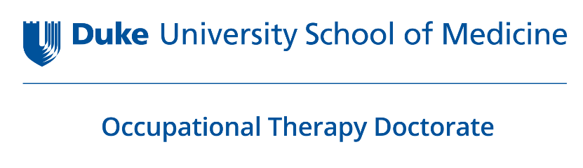
Regular Rank Faculty Position
Assistant or Associate Level
Academic Fieldwork Coordinator
Occupational Therapy Doctorate Division
Duke University
Durham, North Carolina

Academic Fieldwork Coordinator Job Description & Position Criteria

Innovative fieldwork education is key to achieving the Duke OTD vision, aim, and outcomes. The Academic Fieldwork Coordinator role at Duke is full-time and involves seven key areas for supporting excellence in fieldwork. These include providing direct support to students and educators, using instructional design principles and teaching, recruiting and developing fieldwork sites, assessing fieldwork outcomes, administering fieldwork systems, and contributing to the program, institution, and profession. Examples of tasks within each of the key areas of the AFWC role follow. This is a 12-month position. The start date is negotiable.

Support for Students
- Collaborate with students to identify interests, career goals, learning strengths and opportunities, life context, and accessibility needs.
- Actively coach students in fieldwork site selection.
- Actively address actions for improving student success during Level I or II fieldwork.
Support for Educators
- Create infographics, video, online and in-person workshops that explain the Duke OTD curriculum and implications for fieldwork.
- Survey educators about continuing professional development needs related to practice education.
- Support fieldwork educators in exemplifying Duke OTD’s commitment to equity, diversity, inclusion, and belonging.
- Actively address educator actions for improving student success during Level I or II fieldwork.
Instructional Design and Teaching
- Design and implement occupation-centered courses that prepare students for fieldwork.
- Design and implement continuing education for fieldwork educators in practice education theory and methods.
- In collaboration with Duke OTD faculty, design and implement four courses involving one week of simulation activities and one week of learning experiences in practice settings that help students transfer didactic learning to practice.
- Create and maintain Canvas sites for fieldwork related courses.
Fieldwork Site Recruitment and Development
- Increase the program’s pool of community fieldwork partners whose work aligns with the Duke OTD curriculum framework.
- Coach new sites in developing learning outcomes and objectives that reflect the Duke OTD curriculum framework.
- Collaborate with Duke legal personnel and OTD staff to establish contractual agreements with all sites.
- Ensure all sites are knowledgeable and committed to Duke OTD’s equity, diversity, and inclusion learning practices.
- Conduct site visits.
Fieldwork Scholarship
- Conduct and disseminate collaborative research related to occupation-centered learning in Fieldwork.

Fieldwork Administration
- Develop and implement outcomes, policies, procedures, materials and assessments for the Duke OTD fieldwork program.
- Systematically collect and analyze fieldwork data to assess outcomes.
- Collaboration with staff to manage fieldwork databases, ensuring all regulatory and program specific requirements are met and all site information is current.
- Continually revise Fieldwork handbook, fieldwork website.
- Oversee the fieldwork office staff.
- Ensure all fieldwork accreditation standards are met.
- Contribute fieldwork data to ACOTE self-study and annual reports.
Contributions Beyond Fieldwork
- Actively participate in all curriculum design, development, and assessment with particular emphasis on integrating fieldwork and coursework.
- Collaborate with the Capstone Coordinator on efficiency of shared systems.
- Represent Duke University OTD at regional and national meetings.
- Assume leadership roles in regional and national fieldwork initiatives.
- Participate in committees within the department, School of Medicine, and University.
- Collaborate with the department team, making positive and critical contributions.

Position Criteria

Required Credentials
- A minimum of 3 years of demonstrated expertise in occupation-centered occupational therapy;
- A completed doctoral degree;
- Eligible for licensure as an occupational therapist in the state of North Carolina.

Required Criteria
- Direct experience with diverse, minoritized and marginalized groups;
- A demonstrated commitment to addressing equity, diversity and inclusion (EDI) in and through occupational therapy practice and education;
- An expressed willingness to learn about and develop an innovative fieldwork program that reflects the concepts of occupation, integrative learning, and EDI principles;
- Experience in instructional design and assessing learning outcomes;
- Experience in program development;
- An established trajectory of successful mentorship and coaching;
- Demonstrated excellence in negotiating and mediating needs of multiple partners;
- Proven positive, team collaborations;
- Demonstrated engagement in the profession (local, regional, national);
- Excellent skills in communicating to diverse groups and organizing multiple parts of a system.

Preferred Additional Criteria
- Minimum of two years academic experience.
- Experience as an AFWC.
- A terminal academic degree (PhD, EdD, ScD, DSc).
- Knowledge and experience in developing simulated learning experiences.
- Experience conducting and disseminating collaborative research related to occupation-centered learning in fieldwork.

All qualified candidates should send 1) a letter that addresses each of the above criteria, 2) a statement outlining the candidate’s approach to or views on fieldwork education, 3) a curriculum vitae, and 4) contact information for three references.
Priority will be given to applications received by February 21, 2023. Submit materials by email to: Terri Heggie at terri.heggie@duke.edu.

Inquiries can be directed to Barbara.hooper@duke.edu.

Duke University and Department of Orthopaedic Surgery is an Affirmative Action/Equal Opportunity Employer and are committed to increasing the diversity of its faculty, staff, and learners without regard to an individual's age, color, disability, genetic information, gender, gender identity, national origin, race, religion, sexual orientation, or veteran status. We consider diversity and inclusion a critical core value of the institution.

